
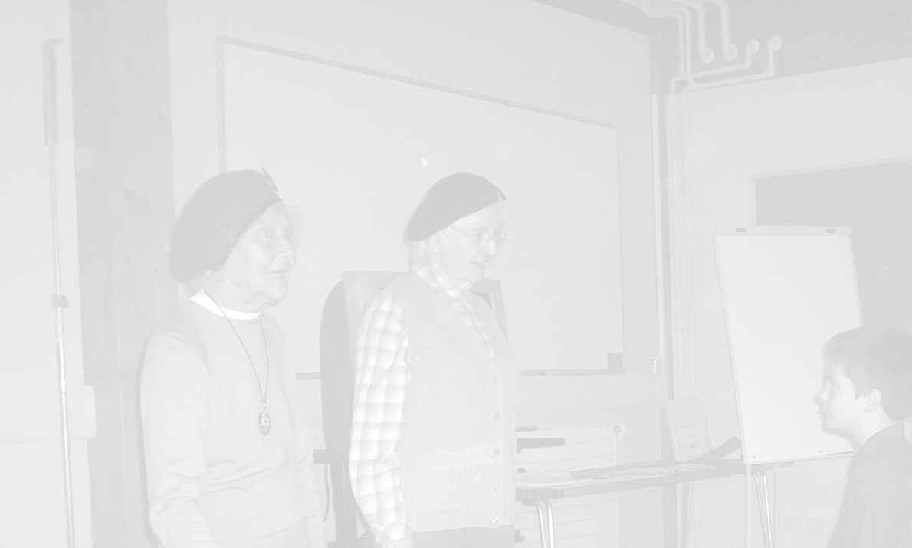
Images Of War
Key Question What do pictures/photographs really tell us about the war years?
How can we tell if they are reliable sources of evidence?

Objectives
To investigate images as reliable sources of evidence.
To make predictions based on evidence
To produce art work based on the evidence

National Curriculum Ref
KS2 Unit 2 a,c Knowledge and understanding of events people and changes in the past.
KS2 Unit 3 Historical Interpretation
KS2 Unit 4a,b Historical Enquiry
KS2 5a,b,c Organisation and Communication
KS2 Unit 11b Britain since the 1930’s

Resources
A selection of photographs and pictures depicting life during the war
www.iwm.org.uk/collections
www.tate.org.uk

Activity
Pupils work in pairs to investigate one of the images.
What can you see?
Do the people know they are being photographed?
Are they posing?
Why was the picture taken?
What sounds do you think their may have been when the image was captured?
What smells surround the scene?
What may the characters be saying or thinking?
Does this picture give you a good idea of what life may have been like during the war? Give reasons for your answer

Ask children to predict what will happen one minute and then one hour after the image was captured and give reasons behind their prediction.
Pupils can then illustrate their prediction using various art forms, (paint, charcoal, pastels, collage etc)

Plenary
Ask children to write a short account of their art work for a display. Use the above questions as a framework for their account.

Cross curricular
Art and Design
1a, b,c Exploring and developing ideas
2, b,c Investigating and making art, craft design
3a, b Evaluating and developing work
4a, b,c Knowledge and understanding
5a,c, d Breadth of study

Opportunities for Extension
As part of a drama lesson pupils create a “freeze frame “ of a scene depicting one aspect of the Second World War (Blitz, evacuation, rationing, bad news, farewells ,land army ) other pupil’s thought tap and discuss the outcomes. Pupils could then develop the frame into a short play developing characters, story line and emotions.
These could be performed in assembly for the rest of the school.

Opportunities for ICT 3a,b, 4a,b,c, 5b
Using a digital camera, pupils could capture their freeze frames. The images can once again be annotated for use in a class display or book,
Using video camera pupils can record their plays. Afterwards pupil’s can evaluate this work. Is it a reliable source of evidence, telling us what life was really like in WW2? How can it be improved?

.

